This feature release includes a number of enhancements to invoices, reports and general functionality.
Please share this with all relevant staff at your property.

We'd love to hear your feedback on our new features; please feel free to use the Comments section below.

Contents
- Default Housekeeper for rooms
- Configurable option for whether to show room numbers on pro-forma invoices
- Trial Balance Reports – Preview
- New column on Occupancy report
- Invoice Option for showing breakdown of Room Charges
- Minimum occupancy on room types
- Changes to Registration Card
- Confirmation emails linked to rates
- Remove 'CC' address from emails
- Changes to Invoicing – Printing invoices in bulk. Guest Name on Invoices?
- End of Day House Accounts - Event Date
- Add card type column to the Payments and Postings reports
- Improved repeat guest flagging
- New Management Reports
- Add pop-up notes to Corporate Accounts / Individuals
- Lost Property log
- House accounts - storing credit cards
- Rooms cancelled after expiry date
- Disable Auto Allocation On Day of Arrival
- Allow users to assign different charge privileges to different dates
- Add notes on email confirmations sent to guests
- User adding individual report as activity
- Provisional bookings to send reminder emails.
- Reservation Report
- Booking.com reservations with added extras
- Export or email of an invoice to include Additional Info
- CRM profile Preferences and Notes
- Room schedule showing if room paid
- Booking Engine – Multiple Languages

Default Housekeeper for rooms
At the request of a member of the HOP community, we have introduced the ability to assign a Default Housekeeper to your rooms. This is configurable from the Rooms > Room Setup page. This housekeeper will thereafter be assigned to their corresponding room when the room becomes “dirty” from either the Night Audit or directly from the Housekeeping > Room Status page.

Configurable option for whether to show room numbers on pro-forma invoices
We have added a setting to either show or hide room numbers on pro-forma Invoices. This will be set to on however if you wish to turn this off you will find it under Administration > Property then at the bottom of Property Settings. Once selected click Update Settings to save.
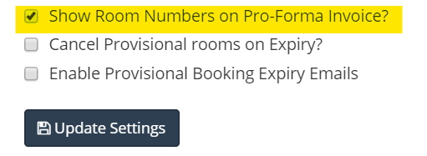
Trial Balance Reports – Preview
We have now added a Print Preview button to the Trial Balance report, to enable you to quickly access the full report, either onscreen or by printing it out, without the need to download the PDF first.
New column on Occupancy report
A new column has been added to the occupancy report to show the adjusted occupancy, removing out of service rooms from your occupancy.
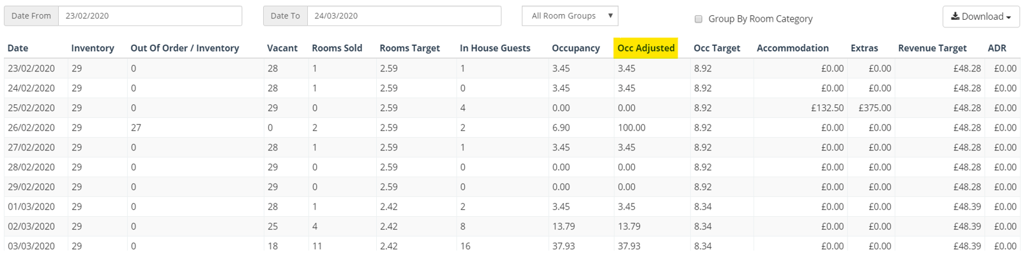
Proforma Invoices broken down by Room Charges
Proforma Invoices are now broken down by room charges. You can now see transactions on the Pro forma invoices broken down by each transaction type.

Minimum occupancy on room types
We have added the option to set a minimum occupancy on room types. This will, for example, prevent an individual person booking larger room types like Family Rooms. This can be set under Rooms > Room Types

Changes to Registration Card
The default HOP registration card now includes a line specifically for car registration numbers. If one has already been entered on the reservation item (i.e. the room reservation) this will automatically pull through onto the card. If not, the system will then look to see if the guest has a registration number on their CRM profile and add it from here. Failing that, the car registration number field will be left blank for the guest to fill in when you print off their card.

Confirmation emails linked to rates
You can now create a rate-specific email template, including the cancellation policy, and link it to a rate plan. If the rate plan is booked this email template will then be sent to the guest. (If multiple rate plans are booked then the default confirmation email will be sent.)
To set this up, create the template in Administration > Email Templates. Then go into the rate plan you wish to set this for under Rates > Rate Plans and select the template from the drop-down list at the bottom of the Details tab.
N.B. For the rate-specific email to be sent for Group Reservations, the Group Reservation Type needs to be Individual, as opposed to Tour Group Or Corporate, and all have the same rate plan.

Remove 'CC' address from emails
We have added a setting to give you the option to stop receiving a copy of guest confirmation emails. If you wish to turn this off, go to Administration > Property where you will see a tick box to turn off CC notifications under ‘Property Settings’.
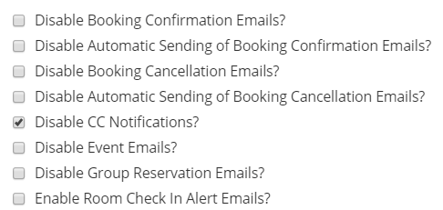

Invoice Optimisation -
Print Summarised Invoice from House Accounts
Printing bills in bulk
Guest name on invoices

End of Day House Accounts - Event Date
If your EPOS has End of Day functionality (i.e. creates a daily house account of all till transactions) we have now implemented a minor change so that the date on the End of Day files is automatically added as the “Event Date” of the house account.
Add card type column to the Payments and Postings reports
Added Column Within the CSV download of the Payments and postings report to include an extra column for card type
Reports > finance > (Payments or Postings)
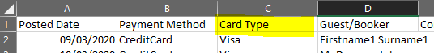

Improved repeat guest flagging
To help HOP users identify repeat customers much more easily, we have made several changes – both visually and in terms of reporting.
- Manage Reservations – If you attach an individual to a reservation who has stayed with you before, you will see a star next to their name and a green highlight.
- CRM – You will now see that the top right corner of each person’s profile now contains a counter which displays how many times that person has stayed with you before. A new tab down the left-hand side of the profile lists all of their previous reservations, in a similar fashion to the Correspondence tab.
- Report – We have created a new CRM report called the Preferences Report, which can be filtered by arrival date, stay date, number of stays and preference types.

New Management reports
Under Reports > Management we have added a new Daily Overview report -
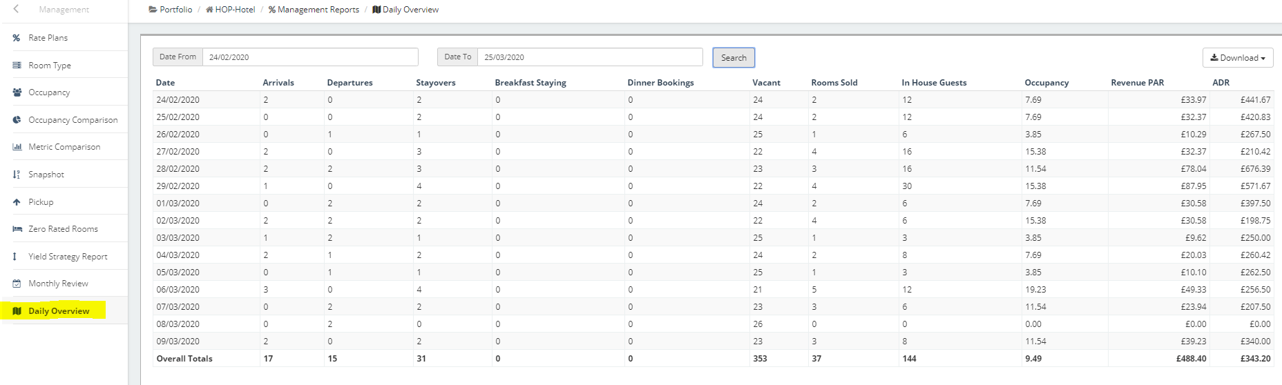
And a new Monthly review report –
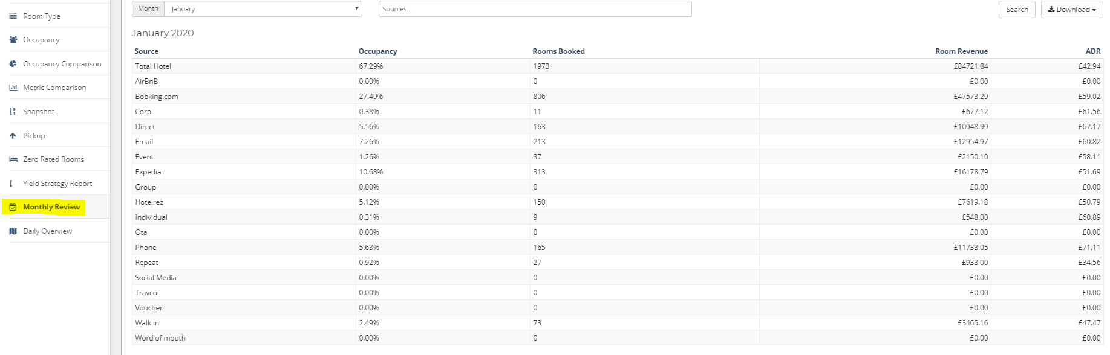
Add pop-up notes to Corporate Accounts / Individuals
Added Feature when adding a corporate or Individual profile to a reservation you now get a pop up with any notes attached to the profile.
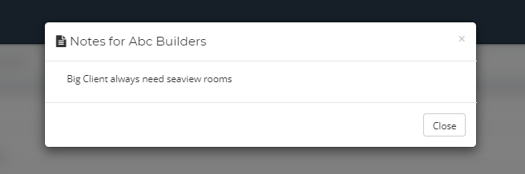
Lost Property log
A log number has been added to each lost property listing (including historic entries). This gives you a number that can be tagged to the item and referenced.
Storing credit cards on Corporate Profiles
Added the ability to store cards on corporate Profiles.
CRM > Corporate > Edit Company
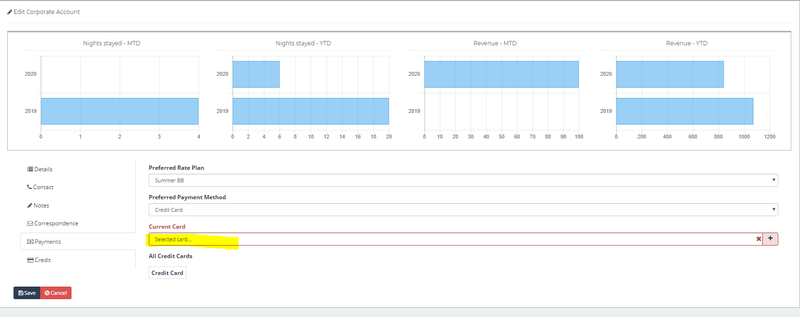
Cancel Provisional Rooms on Expiry
Added the Ability to Cancel provisional rooms automatically within HOP.
To enable this feature go to administration > Property > property settings

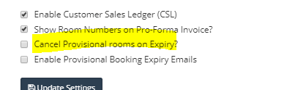

Disable Auto Allocation On Day Of Arrival

Added the ability to disable auto allocation of rooms on the day of arrival.

Administration > Property > Property Settings

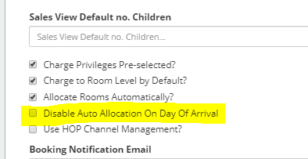

Allow users to assign different charge privileges to different dates
Following feedback from several members of the HOP community, we have now introduced the ability to assign different charge privileges on different days of a stay. This uses the same functionality as split bookings, so to access it you need to click on the drop-down menu next to the reservation item (RESX) number and scroll down to Split Reservation Item. Once this screen opens up, add in the date of the change and choose where you want charges to be sent as of this date:

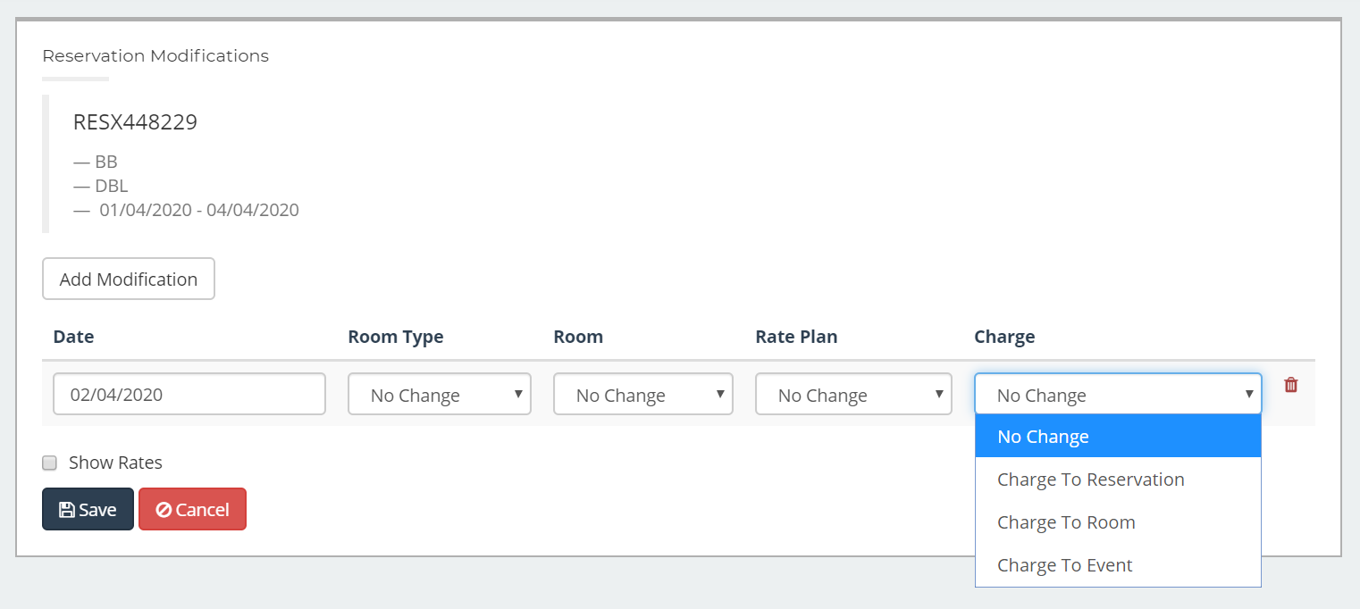

How might this be useful? It might be the case that on most occasions you have wedding guests that stay for two nights. On the first night, the guests pay for themselves so everything gets charged to the bedroom reservation and then on the second night the Bride & Groom pay for the accommodation, so everything would need to be charged to the overall reservation.

Please note that this change affects all charges (accommodation, extras, services, food & beverages) for the date in question, not just accommodation.
Add notes on email confirmations sent to guests
New note box added within reservation called Notes for Guest
Information from within this box can now be displayed within email confirmations by using the new tag within email templates called ‘NotesForGuests’

User adding individual report as activity
Enhanced User Rights by adding the ability to select individual reports that a user will have access to.
Users > Manage users / Manage user Roles > Activities

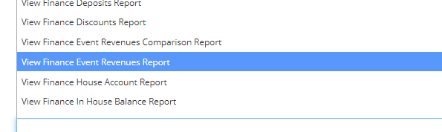
Now instead of having access to a section of reports you can now select individual reports for users to have access to.

Provisional bookings to send automatic emails
Added the ability to enable automatic emails for provisional bookings after expiry date. This can be enabled within property settings.
Administration > Property > Property Settings
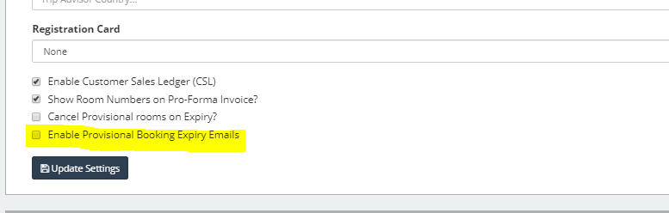

Lead Channel Report
Added a new report Called Lead Channel Report. This report shows all reservations and revenue created broken down to the channels i.e. booking.com and booking engine within selected days.
To find this report go to reports > CRM > Lead Channel Report

Booking.com reservations with added extras
We have enhanced our connection with booking.com so that if a guest edits their reservation to add something with an extra charge, not only will the price in HOP get automatically updated but a note will be added to the reservation to indicate what has been added. This will be particularly useful in scenarios when a guest books with you on a Room Only rate but then chooses to add breakfast later on.

Export or email of an invoice to include Additional Info
We have now added new menu options on the reservation and house account transaction screens so that you can send customer invoices that include the additional information (notes, comments etc.) that you add to individual transaction. Previously you could only print an invoice including its additional information but now you have the option to email it directly to the customer or export (download) it to your computer.

Please remember that you can update this information at any time by clicking on the drop-down menu in the Payment Type column of the transaction screen:

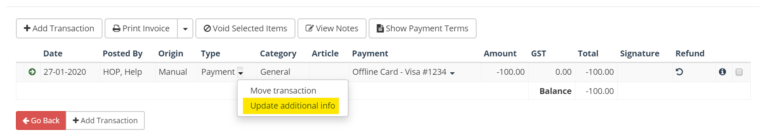

CRM profile Preferences and Notes
We have now made the information that you enter on a guest’s profile in CRM much easier to access on a day to day basis. You can now see the Preferences and Notes from the person’s CRM profile in the following places:

- Manage Reservations / In House list – Click on the “heart” icon to display a pop-up window with this information on it.
- Reservation Articles report – Simply click on the guest’s name to being up the information

Room schedule showing if room paid
To help make the Room Schedule view even easier to understand at-a-glance, the “coloured corners” on reservations, which are used to indicate payment status, have been adjusted so that from now on the coloured corner will only appear once transactions have been added to the reservation.
Booking Engine – Multiple Languages
We have added the option to offer additional language options to customers on your Booking Engine. You can set this up under Administration > Booking Engine
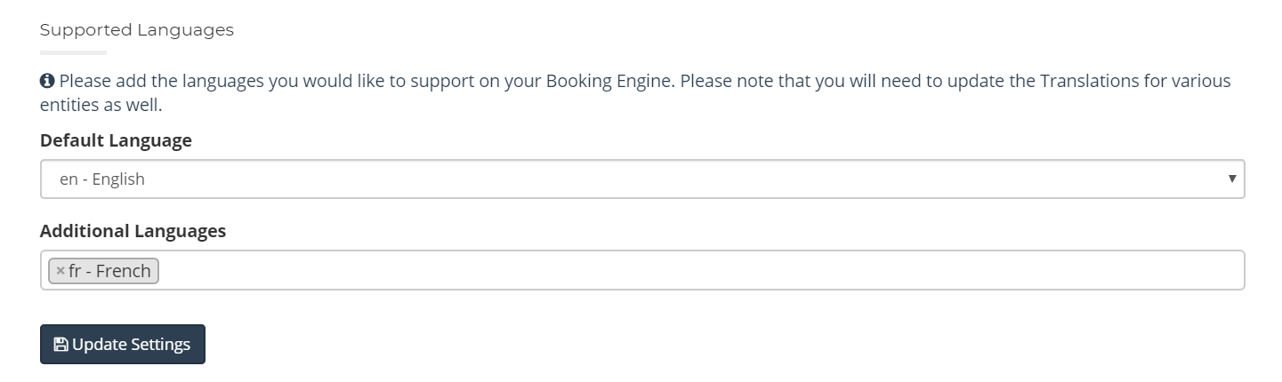
Please contact help@hopsoftware.com should you wish for us to bring in Support for additional languages.

